The Electrostatic Emulator

This program offers a simulation of the motion of spherically symmetrical, charged particles solely under the dynamics of electrostatic forces in a plane, by Coulomb’s Law.

The primary interest lies in the visualization of the kinematic patterns of charged particles as to better understand the influence of the force. Indeed, for a student first introduced into the study of electrostatics, as well as gravitation and planetary motion, which can be described by similar dynamics, this emulator offers an intuitive understanding of the behavior of charged particles. Furthermore, it may serve as a useful companion for experiments along his/her study. 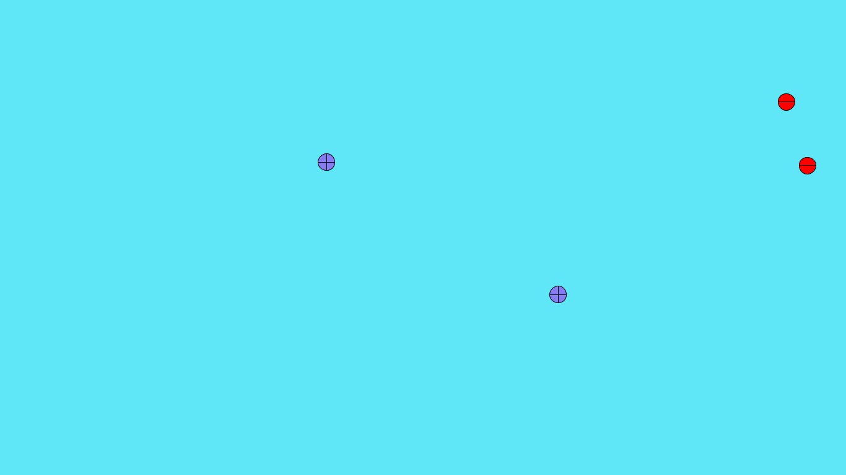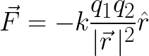

The frame-based system of the programming language Processing, in which this program is written, renders a succinct view of procedure. The general process of the algorithm is the calculation of accelerations of all particles each frame and the increment of the velocities and positions of such particles accordingly. All such quantities, along with the mass and charge, are stored. A method computes the acceleration of two particles based on their electrostatic force and store them. Performing such calculation between all charges yields the dynamic state of the system. Succeedingly, the velocities and accelerations are incremented in accord with the duration given by the frame rate. 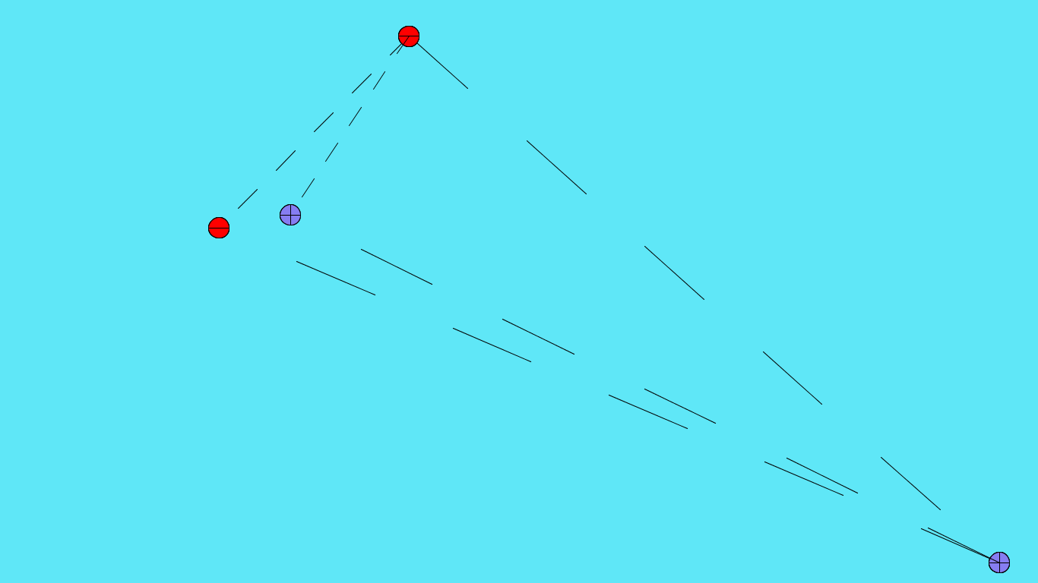

A concise visualization of the internal calculation is provided by connecting particles with dashed lines indicating the computation of electrostatic forces between such particles. Pressing “tab” presents this effect.

Upon the case a charge is exceeding the boundaries of the screen, the wall of the container, the screen, reverses the according velocity in transgression and accounts for the electrostatic work done in this process.

Upon the occasions in which two charges may collide such that interiors do overlap, two assumptions are employed—between charges of different signs, it is assumed that an atom is formed with the negative charge incorporate into the orbital of the positive, which would then gradually fade in color and ultimately ignored; between charges of the same sign, the two particles fused into one particle with the summed charge and mass, which proceeds in a random direction. Despite that the crudity of such assumptions are plainly perceived, as the tenor and purport of this simulation rests solely in the motion of charges under simple standard conditions, they are allowed.

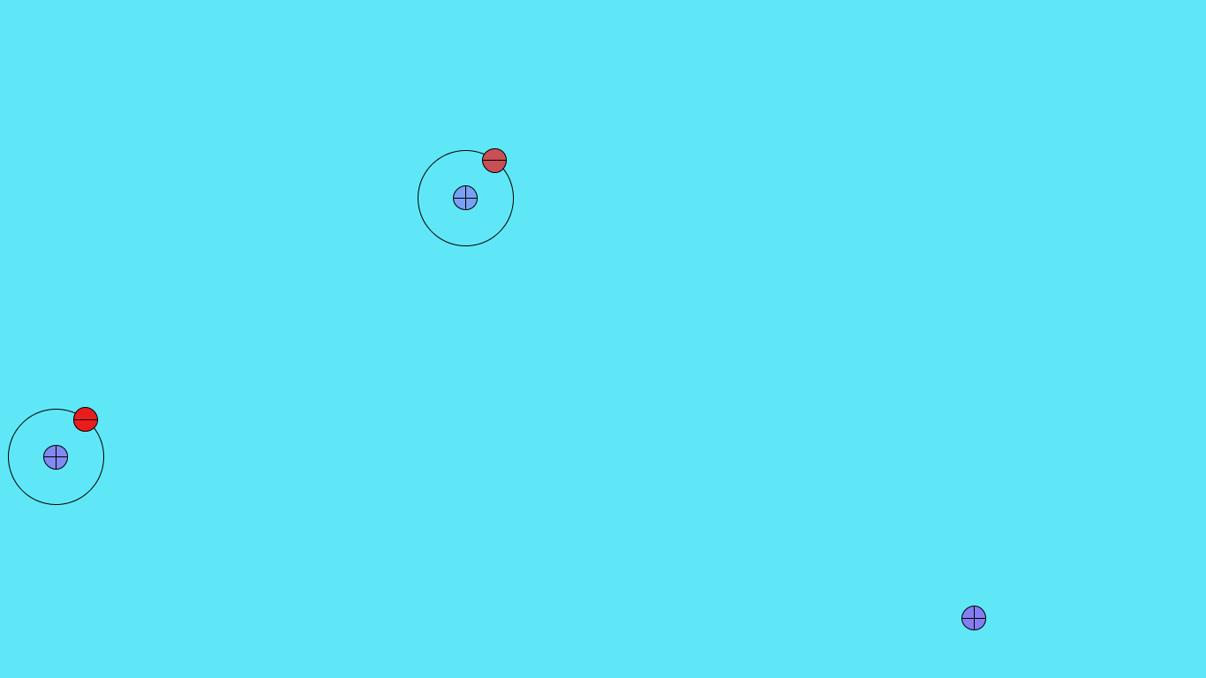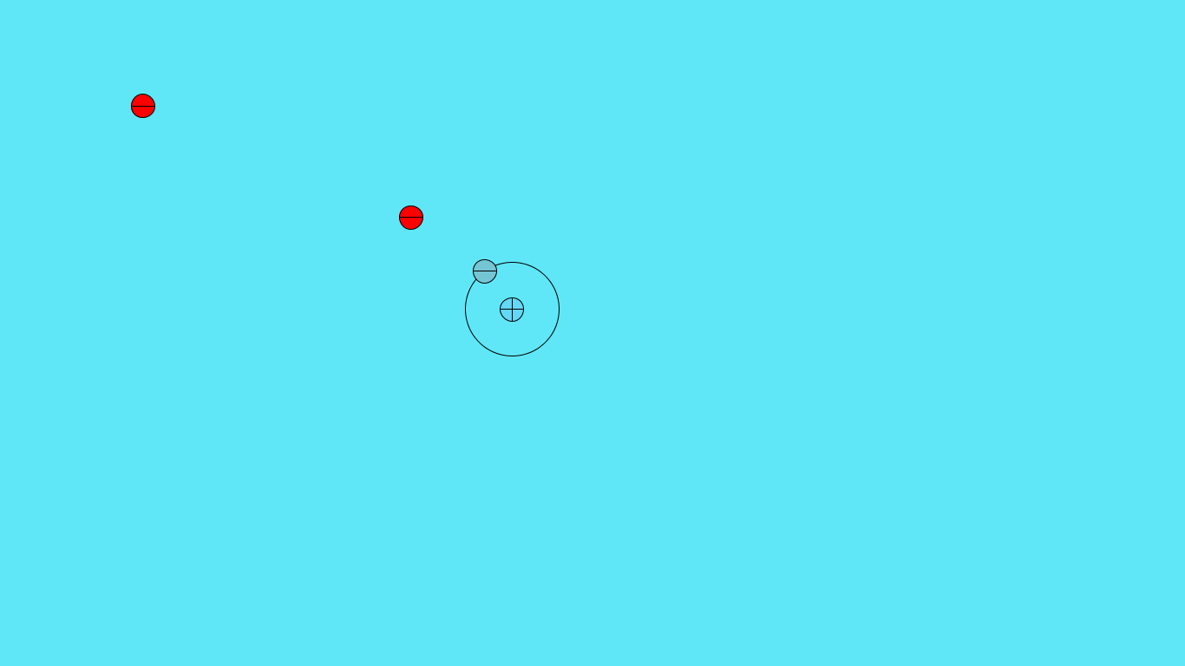

The overall runtime of such a program per frame is *O*(*n*^2). It should be noted that *n* accounts for charges that may have experienced collisions previously as well.

This program can be inspected at the repository <https://github.com/epicderek/Electrostatic-Emulator>.